**Spring mvc webproject 작성하기 방법 정리**

**방법 1) 전통 방식 – 앞에서 실습으로 경험함**

eclipse에서 File – New – **Dynamic Web Project** 한다.

WEB-INF-lib 폴더에 spring library 파일들을 복사한 후 프로젝트 작성

**방법 2) Maven 사용 – 앞에서 실습으로 경험함**

eclipse에서 File – New – **Dynamic Web Project** 를 선택 한다.

프로젝트 구조가 만들어지면 해당 프로젝트에서 오른쪽 버튼 클릭하여,

Configure – **Convert to Maven project**를 선택한다.

이어서 **pom.xml**에

<dependencies>

<dependency>

<groupId>org.springframework</groupId>

<artifactId>spring-webmvc</artifactId>

<version>3.2.5.RELEASE</version>

</dependency>

</dependencies>

가 있는 것을 확인 한 후 프로젝트 작성

**방법 3) Maven 사용**

eclipse에서 File – New – Spring Project – Simple Spring Web Maven 을 선택 한다.

프로젝트 구조가 만들어지면 해당 프로젝트에서 오른쪽 버튼 클릭하여,

Maven – **Update project**를 선택한다.

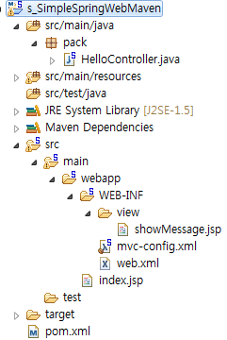

**index.jsp**

<!DOCTYPE html>

<%@ contentType="text/html; charset=UTF-8" pageEncoding="UTF-8"%>

<%@ taglib prefix="c" uri="http://java.sun.com/jsp/jstl/core" %>

<html>

<body>**<a href="hello">Click to enter</a>**</body>

</html>

**web.xml - tool 이 제공함**

<?xml version="1.0" encoding="ISO-8859-1"?>

<web-app xmlns:xsi="http://www.w3.org/2001/XMLSchema-instance"

xmlns="http://java.sun.com/xml/ns/javaee"

xsi:schemaLocation="http://java.sun.com/xml/ns/javaee

http://java.sun.com/xml/ns/javaee/web-app_2_5.xsd"

id="WebApp_ID" version="2.5">

<display-name>s_SimpleSpringWebMaven</display-name>

<context-param>

<param-name>contextConfigLocation</param-name>

**<param-value>classpath:spring/application-config.xml</param-value>**

</context-param>

<listener>

<listener-class>org.springframework.web.context.ContextLoaderListener</listener-class>

</listener>

<servlet>

<servlet-name>dispatcherServlet</servlet-name>

<servlet-class>org.springframework.web.servlet.DispatcherServlet</servlet-class>

<init-param>

<param-name>contextConfigLocation</param-name>

**<param-value>/WEB-INF/mvc-config.xml</param-value>**

</init-param>

<load-on-startup>1</load-on-startup>

</servlet>

<servlet-mapping>

<servlet-name>dispatcherServlet</servlet-name>

**<url-pattern>/</url-pattern>**

</servlet-mapping>

</web-app>

**mvc-config.xml - tool 이 제공함**

<?xml version="1.0" encoding="UTF-8"?>

<…>

<mvc:annotation-driven />

**<context:component-scan base-package="pack" />**

<bean class="org.springframework.web.servlet.view.InternalResourceViewResolver">

<property name="prefix" value="/WEB-INF/view/"/>

<property name="suffix" value=".jsp"/>

</bean>

</beans>

**HelloController.java**

package pack;

import javax.servlet.http.HttpServletRequest;

import javax.servlet.http.HttpServletResponse;

import org.springframework.stereotype.Service;

import org.springframework.web.bind.annotation.RequestMapping;

import org.springframework.web.servlet.ModelAndView;

@Service

@org.springframework.stereotype.Controller

**public class HelloController{**

@RequestMapping({"he*"})

public ModelAndView handleRequest(HttpServletRequest arg0,

HttpServletResponse arg1) throws Exception {

ModelAndView view = new ModelAndView();

view.setViewName("showMessage");

view.addObject("aa", "success");

return view;

}

}

**showMessage.jsp**

<!DOCTYPE html>

<%@ page contentType="text/html; charset=UTF-8" pageEncoding="UTF-8"%>

<html>

<body><h2>${aa}</h2></body>

</html>

**방법 4)에 앞서 Spring Mvc Project 이해 하기**

**Spring MVC project 작성하기**

**메뉴에서 File – new – Spring project 선택**

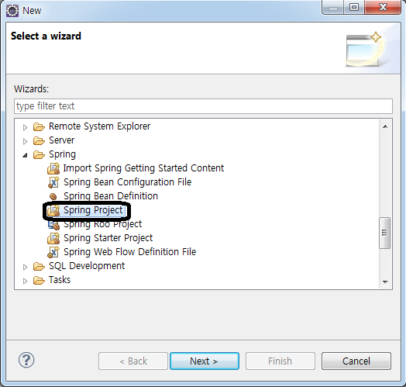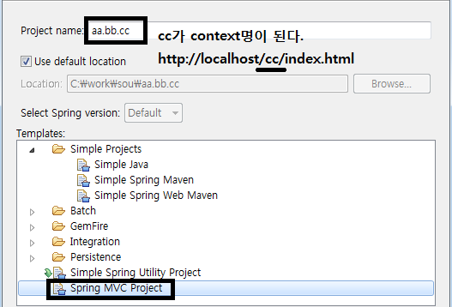

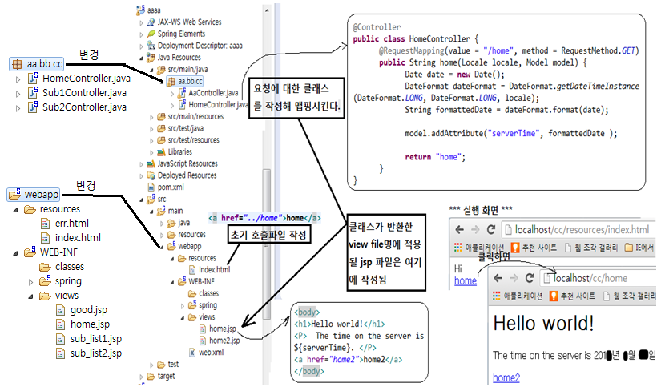

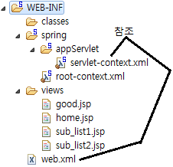

**index.html**

<html>

<body>메인<br/>

**<a href="../home">go home</a><br/>**

**<a href="../good">go good</a><br/>**

</body>

</html>

**web.xml**

**servlet-context.xml**

…

**<context:component-scan base-package="kr.hbi.ex1" />**

**<beans:bean id="/good"**

**class="org.springframework.web.servlet.mvc.ParameterizableViewController">**

**<beans:property name="viewName" value="good" />**

**</beans:bean>**

</beans:beans>

**HomeController.java**

package kr.hbi.ex1;

import java.text.DateFormat;

import java.util.*;

import org.springframework.stereotype.Controller;

import org.springframework.ui.Model;

import org.springframework.web.bind.annotation.*;

**@Controller**

**public class HomeController {**

**@RequestMapping(value = "/home", method = RequestMethod.GET)**

**public String home(Locale locale, Model model) {**

Date date = new Date();

DateFormat dateFormat = DateFormat.getDateTimeInstance(DateFormat.LONG, DateFormat.LONG, locale);

String formattedDate = dateFormat.format(date);

model.addAttribute("serverTime", formattedDate );

return "home";

}

}

**home.jsp**

<%@ page contentType="text/html; charset=UTF-8" %>

<%@ taglib uri="http://java.sun.com/jsp/jstl/core" prefix="c" %>

<%@ page session="false" %>

<html>

<body><h1>Hello world! </h1>

<P> The time on the server is ${serverTime}. </P>

**<a href="sub1">sub1</a>**

<br/>

**<a href="sub2?irum=tom">sub2-sub_list2가 보임</a>**

**<a href="sub2?irum=james">sub2-index가 보임</a>**

</body>

</html>

**Sub1Controller.java**

package kr.hbi.ex1;

import org.springframework.stereotype.Controller;

import org.springframework.web.bind.annotation.RequestMapping;

import org.springframework.web.bind.annotation.RequestMethod;

import org.springframework.web.servlet.ModelAndView;

**@Controller**

**public class Sub1Controller {**

**@RequestMapping(value="/sub1", method=RequestMethod.GET)**

**public ModelAndView home(){**

String msg = "안녕";

return new ModelAndView("sub_list1", "msg", msg);

}

}

**sub_list1.jsp**

<%@ page language="java" contentType="text/html; charset=UTF-8"

pageEncoding="UTF-8"%>

<html>

<body>

결과는 ${msg }

<hr>

<a href="resources/index.html">index</a>

</body>

</html>

**Sub2Controller.java**

package kr.hbi.ex1;

import javax.servlet.http.HttpServletRequest;

import org.springframework.stereotype.Controller;

import org.springframework.web.bind.annotation.RequestMapping;

import org.springframework.web.bind.annotation.RequestMethod;

import org.springframework.web.servlet.ModelAndView;

**@Controller**

**public class Sub2Controller {**

**@RequestMapping(value="/sub2", method=RequestMethod.GET)**

**public ModelAndView abc(HttpServletRequest request){**

String para = request.getParameter("irum");

if(para.equals("tom")){

String msg = para + " 반가워";

return new ModelAndView("sub_list2", "msg", msg);

}else{

return new ModelAndView("redirect:resources/index.html");

}

}

}

**sub_list2.jsp**

<%@ page language="java" contentType="text/html; charset=UTF-8"

pageEncoding="UTF-8"%>

<html>

<head>

<meta http-equiv="Content-Type" content="text/html; charset=UTF-8">

<title>Insert title here</title>

</head>

<body>결과 보기 ${msg}

</body></html>